***Comparison of SM Manila’s Jollibee Fast Food Restaurant Before and After Installation of Happy plus Card Only Kiosk Machine System Through Discrete-Event Simulation***

**Joana Marie L. Estrella**   
Bachelor of Science in Computer Science

College of Science

joanamarie.estrella@tup.edu.ph

**Elaine S. Andus**Bachelor of Science in Computer Science

College of Science

elaine.andus@tup.edu.ph

**Allana Romero**   
Bachelor of Science in Computer Science

College of Science

allanamae.romero@tup.edu.ph

**Christopher Camañag**Bachelor of Science in Computer Science

College of Science

christopher.camanag@tup.edu.ph

***Abstract*** – Fast food restaurants tend to have a lot of customers due to its popularity and its affordability. In this matter, customers will come and go and with their numbers, longer queues will take effect. Queues are one of the major problems among restaurants as it displeases most customers due to their waiting time, resulting to poor quality of customer service. This study aims to determine the comparison of the before and after of using kiosk machine system with the use of discrete-event simulation.

***Keywords*** *–* **simulation modelling, queuing system, kiosk machine, discrete-event simulation, simio simulation software, Weibull distribution, Gamma distribution**

**I. INTRODUCTION**

In recent years, with the rapid economic development and the spread awareness of time cost, improving service efficiency in queuing is more and more valued by people. However, the queuing problem occurs frequently in everyday life, such as at fast food chain restaurants like the well-known Filipino multinational chain Jollibee. Back in the days when systems are not heavily utilized, businesses used to manage their queues manually. From standing in line, calling out to customers verbally, or issuing them with a handwritten paper ticket. To help manage this problem, a kiosk machine is established and developed. Kiosk machine is a small, stand-alone booth used in high-traffic areas for marketing

purposes, these systems have grown tremendously in popularity due to the demand for more automated ordering that is also safe and convenient. It enables contact-free ordering for customers, making it easy and convenient to use. A self-ordering kiosk helps in diverting some of the people away from the counter which reduces the order taking time. It also helps customers navigate through the menu easily and make quick payments. When the food is ready, one can collect the bill generated by the kiosk and the following food ordered.

Simulation can be defined as a series of “what-if” type of experiments that are carried out on the simulation model. Therefore, simulation has a wide range of applications. In this study, a discrete-event simulation approach is utilized to study and analyze the queuing system before and after a kiosk machine system is established at Jollibee branch in SM City Manila. Many studies have been conducted on the queuing system. However, there is not that much research papers on queuing systems that use Simio Simulation Software. In Simio, you can specify how many data points to include, and the software will then show you how many clients were served within a given time unit. In this study the simulation software used is Simio Simulation Software.

Simio Simulation Software is a unique multi-paradigm modeling tool that combines the simplicity of objects with the flexibility of processes to provide a rapid modeling capability without requiring programming. It provides a true object-based 3D modeling environment which allows construction of a 3D model in a single step, from a top-down 2D view, before instantly switching to a 3D view of the system. 3D objects from the Object Library are then simply dragged and placed into the facility view of the model. This research was also assisted by the use of EasyFit software in identifying the distribution of service length and arrival time at Jollibee fast food restaurant. The use of these two software allows for the determination of the queue models for Jollibee fast food restaurant at SM City Manila before and after the establishment of a kiosk machine system. To this end, the purpose of this study is to present a comparison simulation model for a fast-food restaurant through discrete-event simulation.

**II. REVIEW OF RELATED LITERATURE**

This section presents various related literature and studies which are related to the researchers’ topic.

In [1] the study of Chou, and Liu (1999) with the research title of “Simulation Study on the Queuing System in a Fast-Food Restaurant”. The researchers built a simulation model to study the queuing system of a fast-food restaurant located in Taiwan. They also discussed how fast-food restaurants had grown so much in the industry over the last three decades. From the name itself, fast food implies that it is a ‘quick service’ type of restaurant wherein customers would naturally not be expected to wait for a long amount of time to receive service. And this has become one of the key qualities of fast-food restaurants. Even so, there are still waiting lines existing especially during peak hours. The researchers were able to come up with a possible solution to this waiting line problem such as recruiting another server during the said peak hours in order to reduce the customer’s waiting time.

In [2] the study of Dharmawirya and Adi (2011) with the research title of “Case study for Restaurant Queuing Model”. It has been concluded that performing a queuing analysis has been beneficial for a busy restaurant. This study is conducted after observing that some restaurants inevitably lose some customers due to long queuing times. With the help of this queuing model in the research, the restaurant will be able to increase their Quality of Service by having an estimation with regards to how many customers will wait in line as well as the number of customers that will leave each day.

In [3] the study of K. Achimsky, S., Dutkova, and D. Hostakova (2019) with the research title of “Simulation of Queuing System of Post Office”. The paper displays the usage of simulation method as a tool for optimizing costs of post office. For this research specific post office was selected. This post office is situated in town Bytca. The starting point for solving more complicated optimization tasks is to create a system model that includes elements of reality and the relationships between these elements. Simulation methods make it possible to eliminate most of the obstacles that arise from the analytical solution of queuing systems such as queuing system of post office. In contrast to the analytical solution, the stochastic elements of the system are captured by an algorithm in the order to generate the value of random variables in simulation model. The dynamic properties of the system are captured by the time step variable method. The aim of this paper is to use simulation method and optimize number of service counters in the way to save costs. The model of the queuing system that is used in this article is based on two types of events -customer arrival and end of customer service. The model was designed to provide the results of system characteristics. Simultaneous experiments give us the ability to analyze system characteristics and declare conclusions about the system.

In [4] the study of Molla (2017) with the research title of “Case Study for Shuruchi Restaurant Queuing Model”. The researcher described waiting lines and service systems as an indispensable part of the people’s daily lives. No restaurant would want to lose desired customers due to long waits in the queue. And by applying a queuing model, service time can be improved as well as the queuing situation. Arrival rate, service rate, utilization rate, and average waiting time were determined in order to make the model possible. The probability of impatient customers ignoring the system was also considered.

In [5] the study of M. Muntingi et al. (2015) with the research title of “Simulation and analysis of a bank queuing system”. The paper concluded that improving service quality in the banking sector is essential for customer satisfaction. Decision makers are especially concerned about the time that customers wait before receiving their service. To stay competitive, decision makers have to continuously improve their service quality, measured in terms of suitable performance indicators. In this study, we focus on modelling and analysis of bank queuing systems. The study comprises three phases: (i) identify suitable performance indicators that influence customer perception with regards to service quality, (ii) simulate the behavioral performance of bank queuing systems, and (ii) evaluate and improve the service quality of the system. An illustrative case study is presented, showing the utility of proposed simulation approach.

In [6] the study of S., Chowriwar, I., Lade, and P. Sawaitul (2013) with the research title of “Simulation of Queuing Analysis in Hospital”. The researchers concluded that Queuing theory can be used to predict some of the important parameters like total waiting time, average waiting time of patients, average queue length. The simulation of queuing system can be applied to many real-world applications. If it were possible to improve the queues, there would be more profits made and more time to carry out business than ever before, which would be very useful in this fast-paced world. This paper describes the use of queuing systems to decrease the waiting time of patients.

Long waiting list or waiting time in public health is a notorious problem in most of the countries all over the world. Patient flow is a complex phenomenon because of the random nature of the arrival and service of the patients. This requires a systematic approach in planning. Queuing theory and simulation are analytical techniques that are increasingly being accepted as valuable tools. It describes the inter arrival time and service time of the patients coming to the hospital with a suitable distribution. The primary inputs to these models are arrival and service patterns. These patterns are generally described by suitable random distribution. It is found that the inter arrival time of patients follows the Exponential distribution, and the service time follows Normal distribution. Queuing theory is a stochastic approach dealing with random input and servicing processes. As there is a phenomenological analogy between a queuing system and the systems in humans, the aim of the present study was to apply queuing theory with Monte Carlo simulation

design, communication, and commerce. A range of areas for research and development are proposed.

In [7] the study of Bhatt, V., & Tiwari, N. (2014) with the research title of “A Spatial Scan Statistic for Survival Data Based on Weibull Distribution”. The study concluded that the spatial scan statistic has been developed as a geographical cluster detection analysis tool for different types of data sets such as Bernoulli, Poisson, ordinal, normal and exponential. We propose a scan statistic for survival data based on Weibull distribution. It may also be used for other survival distributions, such as exponential, gamma, and log normal. The proposed method is applied on the survival data of tuberculosis patients for the years 2004-2005 in Nainital district of Uttarakhand, India. Simulation studies reveal that the proposed method performs well for different survival distribution functions.

In [8] the study of Kamalov, F., & Denisov, D. (2020) with the research title of “Gamma Distribution-Based Sampling for Imbalanced Data”. The study concluded that the Imbalanced class distribution is a common problem in several fields including medical diagnostics, fraud detection, and others. It causes bias in classification algorithms leading to poor performance on the minority class data. In this paper, we propose a novel method for balancing the class distribution in data through intelligent resampling of the minority class instances. The proposed method is based on generating new minority instances about the existing minority points via a gamma distribution. Our method offers a natural and coherent approach to balancing the data. We conduct a comprehensive numerical analysis of the new sampling technique. The experimental results show that the proposed method outperforms the existing state-of-the-art methods for imbalanced data. Concretely, the new sampling technique produces the best results on 12 out of 24 real lives as well as synthetic datasets. For comparison, the SMOTE method achieves the top score on only 1 dataset. We conclude that the new technique offers a simple yet effective sampling approach to balance data.

In [9] the study of López-Meraz, R. A., Hernández-Callejo, L., Jamed-Boza, L. O., & Alonso-Gómez, V. (2021) with the research title of “Determination of Photovoltaic Power by Modeling Solar Radiation with Gamma distribution in the CEDER Microgrid”. The article proposes a methodology applicable to any photovoltaic (PV) plant to obtain an approximation of the monthly production of solar array power. The analysis was carried out in seven systems of different technologies and capacities, connected to the microgrid of the Center for the Development of Renewable Energies (CEDER) belonging to the Center for Energy, Environmental and Technological Research (CIEMAT) in Soria, Spain. The proposal simulates radiation by combining and crossing two Gamma probability distributions, representing the days with the best and worst solar resources, respectively. As a result, a matrix was created with 12 variables that define the monthly behavior of the radiation. On the other hand, the granularity of the PV generation was homogenized to know it at any moment through polynomial functions. Once both characterizations were known, it was possible to predict the monthly power of each PV array. The methodology has been validated with the measurement approximation index, developed in the text, and with specialized software. The results presented will help in the dimensioning of a backup model and will collaborate in the adequate management of energy.

In [10] the study of Carrasco, J. M., Ortega, E. M., & Cordeiro, G. M. (2008) with the research title of “A Generalized Modified Weibull Distribution for Lifetime Modelling”. In an article, a four-parameter generalization of the Weibull distribution capable of modeling a bathtub-shaped hazard rate function is defined and studied. The beauty and importance of this distribution lies in its ability to model monotone as well as non-monotone failure rates, which are quite common in lifetime problems and reliability. The new distribution has several well-known lifetime special sub-models, such as the Weibull, extreme value, exponentiated Weibull, generalized Rayleigh and modified Weibull distributions, among others. The authors derive two infinite sum representations for its moments. The density of the order statistics is obtained. The method of maximum likelihood is used for estimating the model parameters. Also, the observed information matrix is obtained. Two applications are presented to illustrate the proposed distribution.

In [11] the study of Lai, C. D., Murthy, D. N., & Xie, M. (2006) with the research title of “Weibull Distributions and Their Applications”. The study concluded that Weibull models are used to describe various types of observed failures of components and phenomena. They are widely used in reliability and survival analysis. In addition to the traditional two-parameter and three-parameter Weibull distributions in the reliability or statistics literature, many other Weibull-related distributions are available. A brief introduction to those models, with the emphasis on models that have the potential for further applications was also provided in the chapter as well. After introducing the traditional Weibull distribution, some historical development and basic properties are presented. The researchers also discuss estimation problems and hypothesis-testing issues, with the emphasis on graphical methods.

In [12] the study of Liu, C., Martin, R., & Syring, N. (2017) with the research title of “Efficient Simulation from a Gamma Distribution with small Shape Parameter”. The study concluded that simulating a gamma distribution with small shape parameters is a challenging problem. Towards an efficient method, the researchers obtain a limiting distribution for a suitably normalized gamma distribution when the shape parameter tends to zero. Then this limiting distribution provides insight to the construction of a new, simple, and highly efficient acceptance–rejection algorithm. The proposed method is fast, and comparisons based on acceptance rates show that it is more efficient than existing acceptance–rejection methods.

**III. METHODOLOGY**

The stages of research conducted at Jollibee fast food restaurant in SM City Manila are as follows:

*Data Collection*

Data collection is used to identify the type of distribution that exists in the queuing system at the Jollibee fast food restaurant that are used as important data so that it can be simulated in Simio Simulation Software. The data used are the following: the number of customers (NOC), the arrival time of customers (ATC), and the length of time of service (LTS). Data was collected by direct observation at Jollibee fast food restaurant during work time. Data to be taken is the average time of service (ATS).

*Assumptions*

In this simulation approach, the researchers make the following assumptions.

1. The service at the counter cannot be interrupted once started.
2. The customers solely used the happyplus card to pay at kiosk machines.
3. Customers will automatically pass through the standby area as they decide where to line up at the counters or where to place their orders (either in the counter or kiosk machine).
4. The data was observed during the busy hour of 11:00am – 2:00pm (Lunch Time)

Following the above-listed simplifying assumptions, creating model description methodology was constructed as presented in the next section.

*Creating Model Description*

The data is distributed using EasyFit Software, a distribution fitting software designed to facilitate probability data analysis and best model selection. It allows to easily and quickly select the probability distribution which best fits to data. And the models were designed with Simio Simulation Software, a unique multi-paradigm modeling tool that combines the simplicity of objects with the flexibility of processes to provide a rapid modeling capability. Models developed can determine the comparison before and after the establishment of a kiosk machine system at a Jollibee fast food restaurant in SM City Manila.

*System Design*

The stages in designing the system consist of:

1. Distribution Testing

Distribution testing is performed prior to the establishment of the kiosk machine and after the establishment of kiosk machine. Data that were gathered throughout the observation using EasyFit Software.

1. Making a Queue System Simulation 3D Models

At this stage, the first model is developed in the first event, which is the past data prior to the establishment of the kiosk machine, and the second model is developed in the second event, which is the present data following the establishment of the kiosk machine. Simio Simulation Software was used to create the models, which were based on the type of arrival time distribution, and customer service length obtained from EasyFit Software.

**IV. RESULTS AND DISCUSSION**

This section presents the data and results of the experiment setup which the researchers built and constructed.

*Data Validation*

|  |  |  |
| --- | --- | --- |
|  | Average Time (Seconds) | |
| Process | Case 1 (Real World) | Case 1 (Model) |
| Time of Arrival | 59.79 | 56.90 |
| Duration of Counter Service | 123.06 | 116.0 |
|  | Number of Customers | |
| Total Customer | 150 |  |

*Table 1. Data shown above is the comparison of average data of Case 1 in Real World and Case 1 Simulation Model*

|  |  |  |
| --- | --- | --- |
|  | Average Time (Seconds) | |
| Process | Case 1 (Real World) | Case 1 (Model) |
| Time of Arrival | 59.79 | 46.17 |
| Duration of Counter Service | 123.06 | 121.78 |
| Duration of Kiosk Machine Service | n/a | 68.54 |
|  | Number of Customers | |
| Total Customer | 170 | 239 |
| Served | 157 | 232 |
| Not Served | 13 | 7 |

*Table 2. Data shown above is the comparison of average data of Case 1 Simulation Model and Case 2 Simulation Model*

*Using T-test*

Case 1 (Real World) and Case 1 (Model)

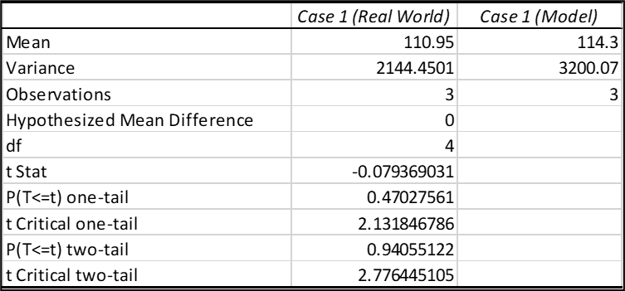

*Based on the table above, Case 1 (Real World) has a mean of 110.95, a variance of 2144.4501, and an observation of 3. Meanwhile, Case 1 (Model) has a mean of 114.3, a variance of 3200.07, and an observation of 3. The two-tailed P value is 0.9235. By conventional criteria, this difference is considered to be not statistically significant.*

Case 1 (Model) & Case 2 (Model)

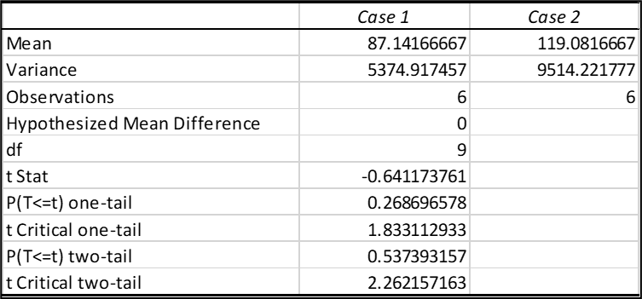

*****Based on the table above, Case1 has a mean of 87.1417, a variance of 5374.9175, and an observation of 6. Meanwhile, Case 2 has a mean of 119.0817, a variance of 9514.2218, and an observation of 6. The two-tailed P value is 0.5374. By conventional criteria, this difference is considered to be not statistically significant.*

*Process Average Time Data*

Data on average time of service at Jollibee Fast Food Restaurant SM City Manila branch can be seen in Table 1.

|  |  |
| --- | --- |
| Process | Average Time (Seconds) |
| Without Kiosk Machine (Case 1) | |
| Time of Arrival | 59.79 |
| Duration of Counter Service | 123.06 |
| With Kiosk Machine (Case 2) | |
| Time of Arrival | 46.17 |
| Duration of Counter Service | 121.78 |
| Duration of Kiosk Service | 68.54 |

  
Table 1. Data on Average Time of Process at Jollibee SM City Manila Branch

In table 1, based on the observation data that has been collected on Jollibee Fast Food Restaurant in total of 100 sampling data, the arrival time for Case 1 is 59.79 seconds while in Case 2 is 46.17 seconds. Preliminary observational data shows the average duration of service in counters in Case 1 is 123.06 seconds while in Case 2 is 121.78. Due to advancement of technology, Kiosk Machines are present in Case 2. The average duration of Kiosk Machine service is 68.54 seconds.

*Distribution Testing*

The following is a distribution test carried out on arrival time and duration of Counter and Kiosk Service that have been collected during observation using EasyFit Software which can be seen in Figures below.

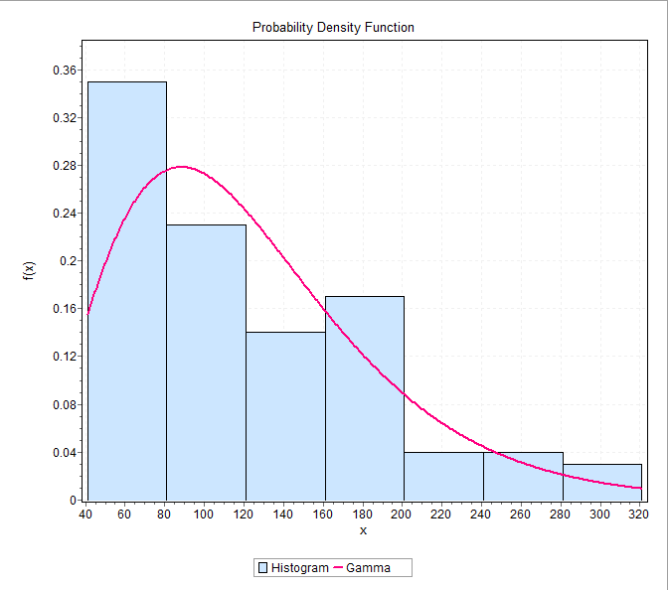Figure 1. Testing of Distribution of Time of Arrival (Case 1)

Figure 2. Testing of Distribution of Duration of Counter Service (Case 1)

Figure 3. Testing of Distribution of Arrival Times (Case 2)

Figure 4. Testing of Distribution of Duration of Counter Service (Case 2)

Figure 5. Testing of Distribution of Duration of Kiosk Machine Service (Case 2)

In case 1, we have 2 figures to illustrate the data distribution. In figure 1, we can see that the distribution of the arrival time is the Weibull distribution while in figure 2, we can see that the distribution of the duration of the counter service is the Gamma distribution.

In case 2, we have 3 figures that illustrate the data distribution. In figure 3, we can see that the distribution of arrival time of customers is the Weibull distribution while in figure 4 and 5, we can see that the distribution are both Gamma distribution for the duration of counter service and kiosk machine service.

*Queue System Model*

At this stage, the researchers created a queuing system simulation made using Simio Software according to the type of data distribution obtained from EasyFit Software. The simulation models can be seen in the figures below.

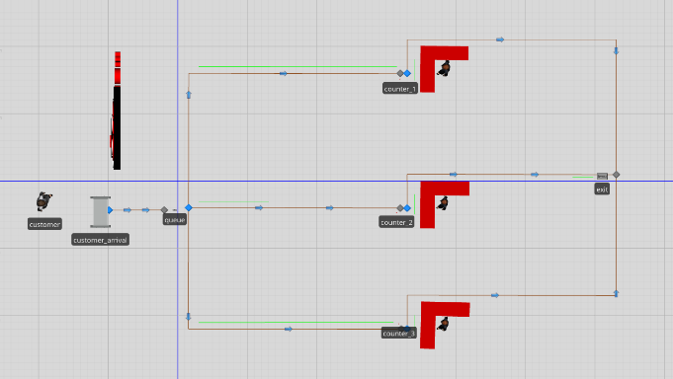

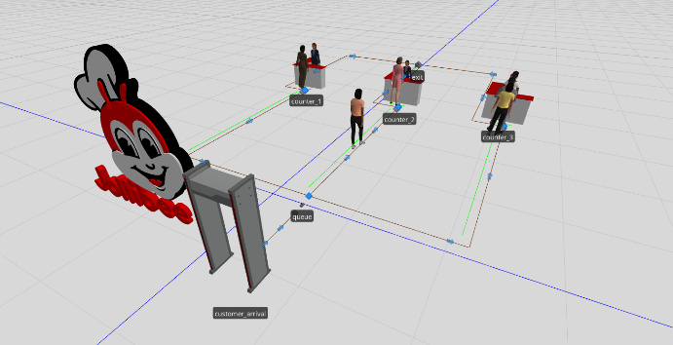Figure 6. 2D Simulation Model of Case 1 (Without Kiosk Machine)

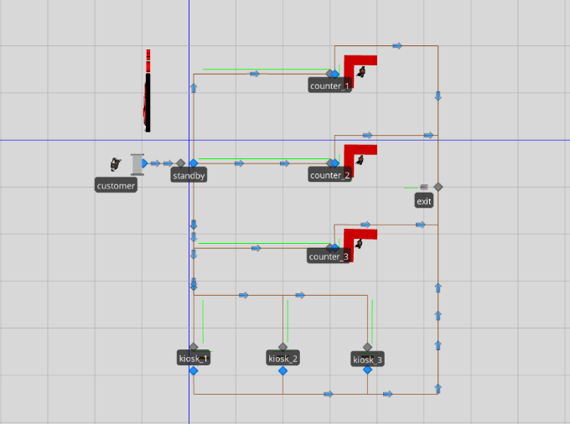Figure 7. 3D Simulation Model of Case 1 (Without Kiosk Machine)

Figure 8. 2D Simulation Model of Case 2 (With Kiosk Machine)

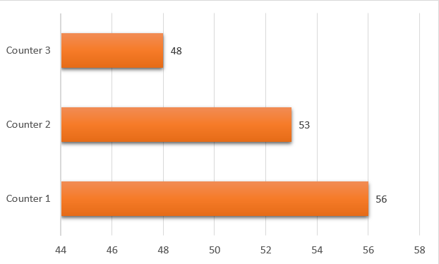

Figure 9. 3D Simulation Model of Case 2 (With Kiosk Machine)

*Case 1- Queuing System Simulation Results*

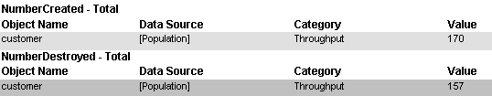After the simulation with Simio Software for Case 1 ( 3 Counters ) that can be seen in Figure 6, the result is that the total number of customers served is 157 out of 170 customers as you can see in the table below.

Table 2. Total number of customers and customers served in Case 1 in the Simulation

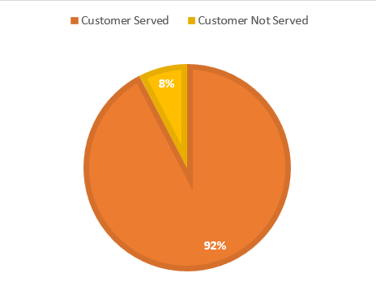

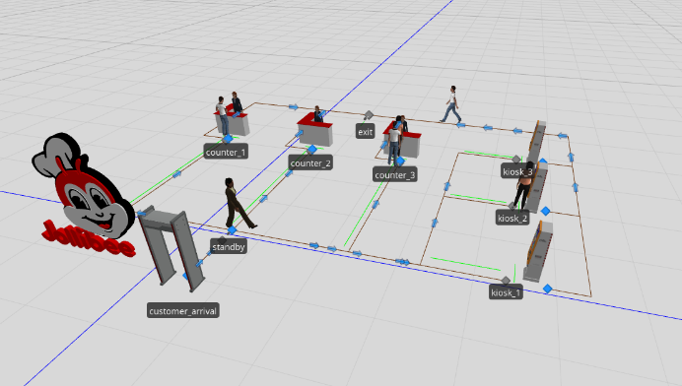

Figure 10. Percentage of the number of customers served and not served during the simulation for Case 1.

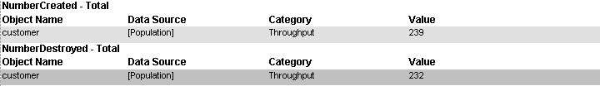Based on the simulation result in Case 1 ( 3 Counters without Kiosk Machine), as we can see in figure 10, 92.35% of the total number of customers are served during the simulation while 7.67% are not.

Figure 11. Number of customers served at each counter of Case 1

Based on figure 11, there are a total of 157 customers served with a percentage of 35.67% for counter 1 (56 customers), 33.76% for counter 2 (53 customers), and 30.57% for counter 3 (48 customers).

Figure 12. Average time of Processing at each counter of Case 1

Based on figure 12, the average service time of each counter is 2.04 minutes at counter 1, 1.91 minutes at counter 2, and 1.85 minutes at counter 3.

*Case 2 - Queuing System Simulation Results*

After the simulation with Simio Software for Case 2 ( 3 Counters & 3 Kiosk Machines) that can be seen in Figure 8, the result is that the total number of customers served is 232 out of 239 customers as you can see in the table below.

Table 3. Total number of customers and customers served in Case 2 in the Simulation

Figure 13. Percentage of the number of customers served and not served during the simulation for Case 2.

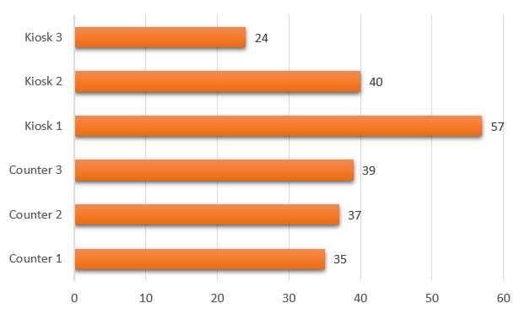Based on the simulation result in Case 2 (3 Counters and 3 Kiosk Machine), as we can see in figure 13, 97.07% of the total number of customers are served during the simulation while 2.93% are not.

Figure 14. Number of customers served at each counter and kiosk machine of Case 2

Based on figure 14, there are a total of 232 customers served with a percentage of 15.09% for counter 1 (35 customers), 15.95% for counter 2 (37 customers), 16.81% for counter 3 (39 customers), 24.57% for Kiosk 1 (57 customers), 17.24% for Kiosk 2 (40 customers), and 10.34% for Kiosk 3 (24 customers).

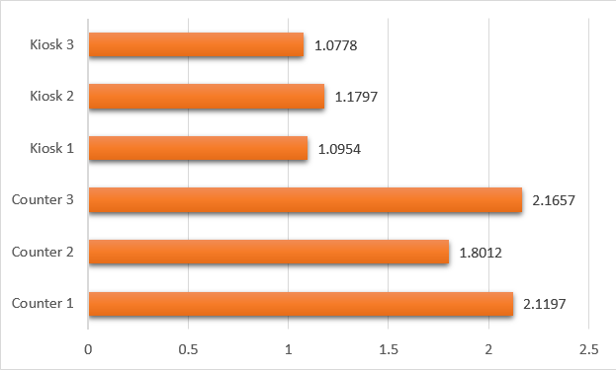

Figure 15. Average time of Processing at each counter and kiosk machine of Case 2

Based on figure 15, the average service time of each counter is 2.12 minutes at counter 1, 1.80 minutes at counter 2, 2.17 minutes at counter 3, 1.10 minutes at kiosk 1, 1.18 minutes at kiosk 2, and 1.08 minutes at Kiosk 3.

**V. CONCLUSION**

After the following simulation, based on the results, the researchers came up with the conclusion that the Case 2 model which is with 3 counters and 3 kiosk machines is the optimal model with 97% of customers being served during the simulation compared to Case 1 model which has 3 counters only and with 92% of customers served. Also, based on the figures presented above, Kiosk 1 with 57 customers in Case 2 Model is the highest customer served during the simulation compared to the other services, and also Kiosk 3 is the shortest processing time among the rest. In conclusion, the addition of Kiosk Machines in the Jollibee Fast Food Restaurant in SM City Manila greatly helps shorten the time of processing and also increases the number of customers served.

**REFERENCES**

[1] Bhatt, V., & Tiwari, N. (2014). A spatial scan statistic for survival data based on Weibull distribution. *Statistics in Medicine*.

[2] Kamalov, F., & Denisov, D. (2020). Gamma distribution-based sampling for imbalanced data. *Knowledge-Based Systems*.

3] Carrasco, J. M., Ortega, E. M., & Cordeiro, G. M. (2008). A generalized modified Weibull distribution for lifetime modeling. *Computational Statistics & Data Analysis*, *53*(2), 450-462.

[4] Chou, C. Y., & Liu, H. R. (1999). Simulation study on the queuing system in a fast-food restaurant. Journal of Restaurant & Foodservice Marketing, 3(2), 23-36.

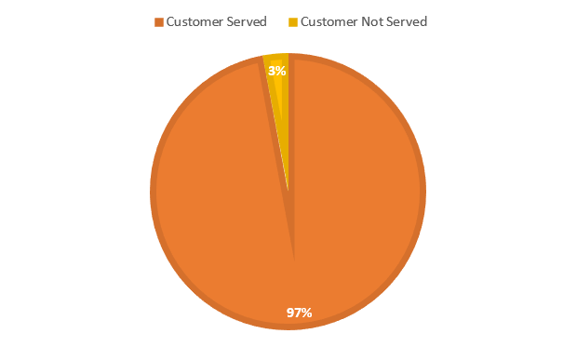[5] Dharmawirya, M., & Adi, E. (2011). Case study for restaurant queuing model. International Conference on Management and Artificial Intelligence.

[6] Ďutková, S., Achimský, K., & Hoštáková, D. (2019). Simulation of queuing system of post office. Transportation Research Procedia (Vol. 40, pp. 1037–1044). Elsevier B.V.

[7] Ishad, L., Sandeep, C., Pranay, S. (2013). Simulation of Queuing Analysis in Hospital. International Journal of Mechanical Engineering and Robotics Research.

[8] Kamalov, F., & Denisov, D. (2020). Gamma distribution-based sampling for imbalanced data. *Knowledge-Based Systems*.

[9] Lai, C. D., Murthy, D. N., & Xie, M. (2006). Weibull distributions and their applications. In *Springer Handbooks* (pp. 63-78). Springer.

[10] Liu, C., Martin, R., & Syring, N. (2017). Efficient simulation from a gamma distribution with small shape parameter. *Computational Statistics*, *32*(4), 1767-1775.

[11] López-Meraz, R. A., Hernández-Callejo, L., Jamed-Boza, L. O., & Alonso-Gómez, V. (2021). Determination of photovoltaic power by modeling solar radiation with Gamma distribution in the CEDER microgrid. *Revista Facultad de Ingenieria*.

[12] Molla, M. A. A. (2017). Case Study for Shuruchi Restaurant Queuing Model. IOSR Journal of Business and Management, 19(02), 93-98.

[13] [Mutingi](https://ieeexplore.ieee.org/author/38233298100), M., [Mapfaira](https://ieeexplore.ieee.org/author/37085354776), H., Moakofi, [N. P. K.](https://ieeexplore.ieee.org/author/37085556793), Moeng, [S. A.,](https://ieeexplore.ieee.org/author/37085565998)  Mbohwa, [C](https://ieeexplore.ieee.org/author/38233300200). Simulation and Analysis of a Bank Queuing System. In [2015 International Conference on Industrial Engineering and Operations Management (IEOM)](https://ieeexplore.ieee.org/xpl/conhome/7085620/proceeding).

**V. CONCLUSION**

After the following simulation, based on the results, the researchers came up with the conclusion that the Case 2 model which is with 3 counters and 3 kiosk machines is the optimal model with 97% of customers being served during the simulation compared to Case 1 model which has 3 counters only and with 92% of customers served. Also, based on the figures presented above, Kiosk 1 with 57 customers in Case 2 Model is the highest customer served during the simulation compared to the other services, and also Kiosk 3 is the shortest processing time among the rest. In conclusion, the addition of Kiosk Machines in the Jollibee Fast Food Restaurant in SM City Manila greatly helps shorten the time of processing and also increases the number of customers served.

**REFERENCES**

[1] Bhatt, V., & Tiwari, N. (2014). A spatial scan statistic for survival data based on Weibull distribution. *Statistics in Medicine*.

[2] Kamalov, F., & Denisov, D. (2020). Gamma distribution-based sampling for imbalanced data. *Knowledge-Based Systems*.

[3] Carrasco, J. M., Ortega, E. M., & Cordeiro, G. M. (2008). A generalized modified Weibull distribution for lifetime modeling. *Computational Statistics & Data Analysis*, *53*(2), 450-462.

[4] Chou, C. Y., & Liu, H. R. (1999). Simulation study on the queuing system in a fast-food restaurant. Journal of Restaurant & Foodservice Marketing, 3(2), 23-36.

[5] Dharmawirya, M., & Adi, E. (2011). Case study for restaurant queuing model. International Conference on Management and Artificial Intelligence.

[6] Ďutková, S., Achimský, K., & Hoštáková, D. (2019). Simulation of queuing system of post office. Transportation Research Procedia (Vol. 40, pp. 1037–1044). Elsevier B.V.

[7] Ishad, L., Sandeep, C., Pranay, S. (2013). Simulation of Queuing Analysis in Hospital. International Journal of Mechanical Engineering and Robotics Research.

[8] Kamalov, F., & Denisov, D. (2020). Gamma distribution-based sampling for imbalanced data. *Knowledge-Based Systems*.

[9] Lai, C. D., Murthy, D. N., & Xie, M. (2006). Weibull distributions and their applications. In *Springer Handbooks* (pp. 63-78). Springer.

[10] Liu, C., Martin, R., & Syring, N. (2017). Efficient simulation from a gamma distribution with small shape parameter. *Computational Statistics*, *32*(4), 1767-1775.

[11] López-Meraz, R. A., Hernández-Callejo, L., Jamed-Boza, L. O., & Alonso-Gómez, V. (2021). Determination of photovoltaic power by modeling solar radiation with Gamma distribution in the CEDER microgrid. *Revista Facultad de Ingenieria*.

[12] Molla, M. A. A. (2017). Case Study for Shuruchi Restaurant Queuing Model. IOSR Journal of Business and Management, 19(02), 93-98.

[13] [Mutingi](https://ieeexplore.ieee.org/author/38233298100), M., [Mapfaira](https://ieeexplore.ieee.org/author/37085354776), H., Moakofi, [N. P. K.](https://ieeexplore.ieee.org/author/37085556793), Moeng, [S. A.,](https://ieeexplore.ieee.org/author/37085565998)  Mbohwa, [C](https://ieeexplore.ieee.org/author/38233300200). Simulation and Analysis of a Bank Queuing System. In [2015 International Conference on Industrial Engineering and Operations Management (IEOM)](https://ieeexplore.ieee.org/xpl/conhome/7085620/proceeding).